

Testing the Phone Insurance

Group 7

Name : Fausta Amral Yudantio

Hilal Ghibran Anshori

Class : 3 SC 5

CEP CCIT

FAKULTAS TEKNIK UNIVERSITAS INDONESIA

2020/2021

**PROJECT ON**

*Testing the Phone Insurance*

**Developed by**

1. **Fausta Amral Yudantio**
2. **Hilal Ghibran Anshori**



**Testing the Phone Insurance**

Batch Code : 3 SC 5

Start Date : November 17, 2020  
End Date : November 19, 2020

Name of Faculty : Muhammad Idham Khalid

Names of Developer : 1. Fausta Amral Yudantio

1. Hilal Ghibran Anshori

Date of Submission : November 19, 2020



**CERTIFICATE**

This is to certify that this report titled “Testing the Phone Insurance” embodies the original work done by Fausta Amral Yudantio and Hilal Ghibran Anshori project in partial fulfillment of their course requirement at NIIT.

Coordinator:

Muhammad Idham Khalid

**ACKNOWLEDGEMENT**

Authors would like to praise to Allah, Most Merciful bless and so authors can finish this Project entitled “Testing the Phone Insurance”. Author would like to thanks to Mr. Muhammad Idham Khalid as Lecturer who has given useful suggestion which are help author in writing this paper.

The writer realized that this paper far from perfection, then the writer will be very unfettered the chest and was encouraged, if colleagues and the guide's agreeing lecturer gave the suggestion & criticism for this paper perfection.

**SYSTEM ANALYSIS**

**System Summary**:

Phone Insurance is an application that calculate the price amount of the insurance that depends on how long the insurance and the quality of the insurance.

**CONFIGURATION**

**Operating System :** Windows 10

**Hardware :** HP Pavillion 14

**Software :** NetBeans 8.2, Apache JMeter

\

sssssssssss

**TYPE OF TESTING TOOLS**

1. JUnit

JUnit is a unit testing framework for java. Used and writed by developer for testing a specific area of a functionality of the code to be tested.

1. Black Box Testing

Black Box Testing is a software testing method in which the internal structure/ design/ implementation of the item being tested is not known to the tester.

1. JaCoCo

JaCoCo is a free code coverage library for Java, which has been created by the EclEmma team based on the lessons learned from using and integration existing libraries for many years.

Testing JUnit

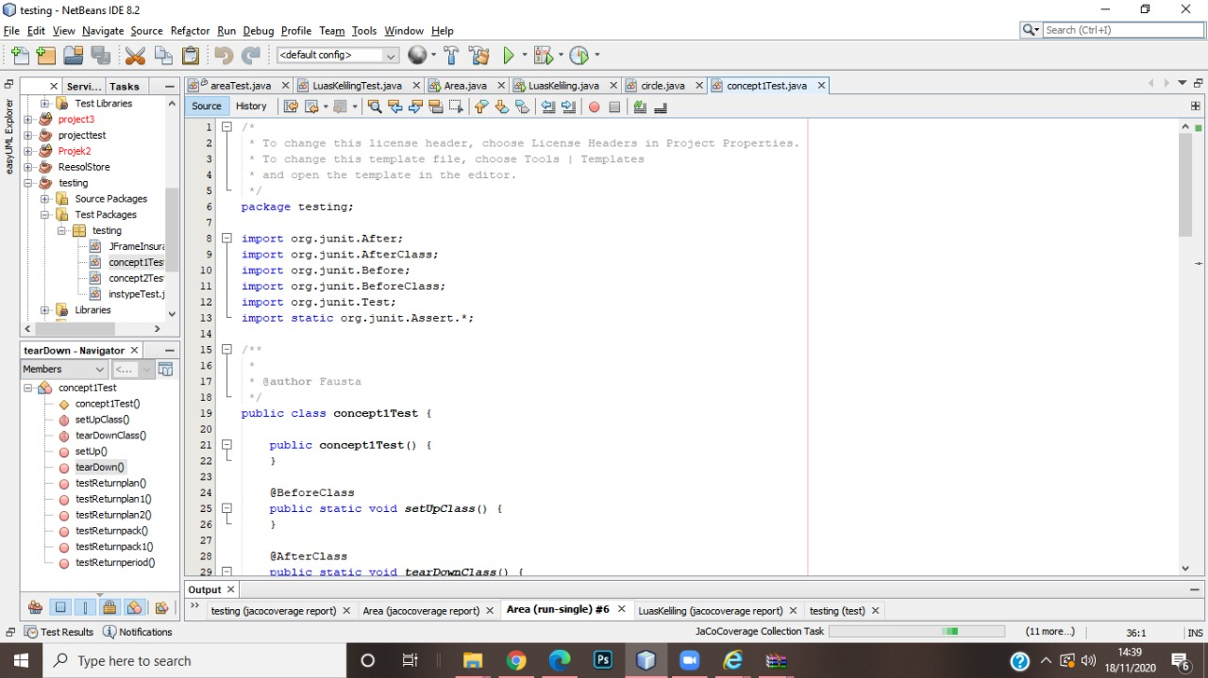

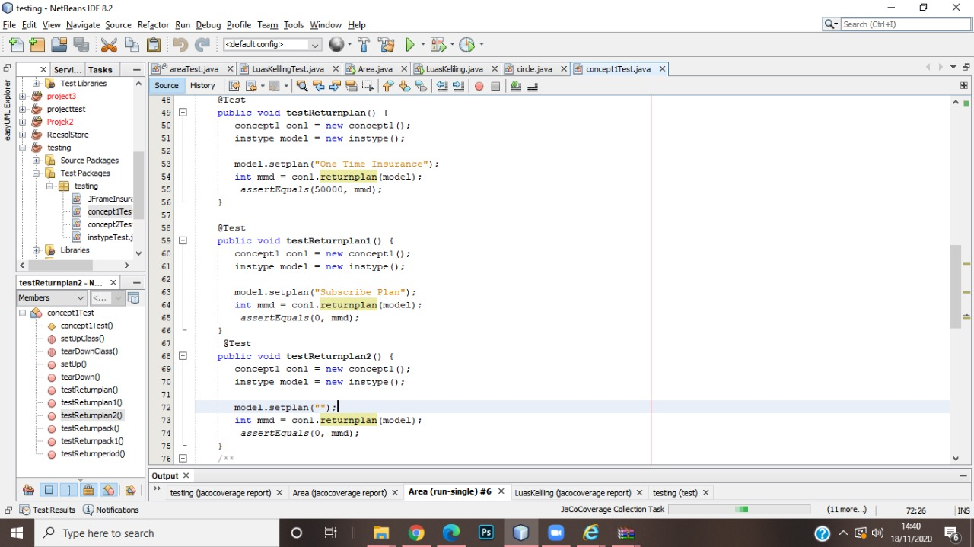

**TESTING IMPLEMENTATION JUnit**

**TESTING IMPLEMENTATION JUnit**

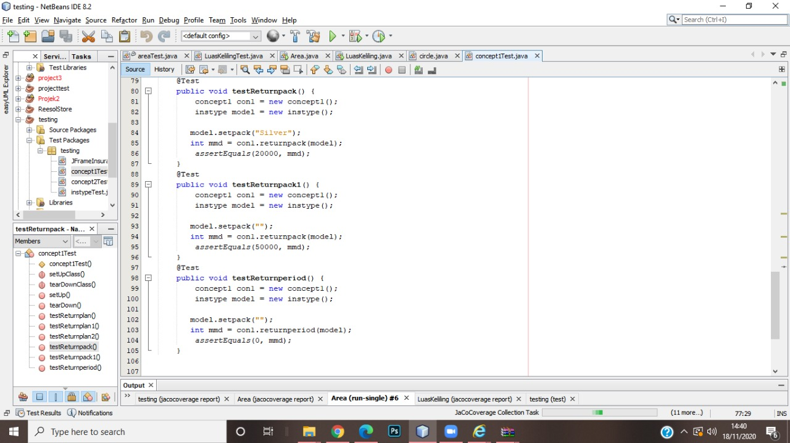

\

sssssssssss

**TESTING IMPLEMENTATION JUnit**

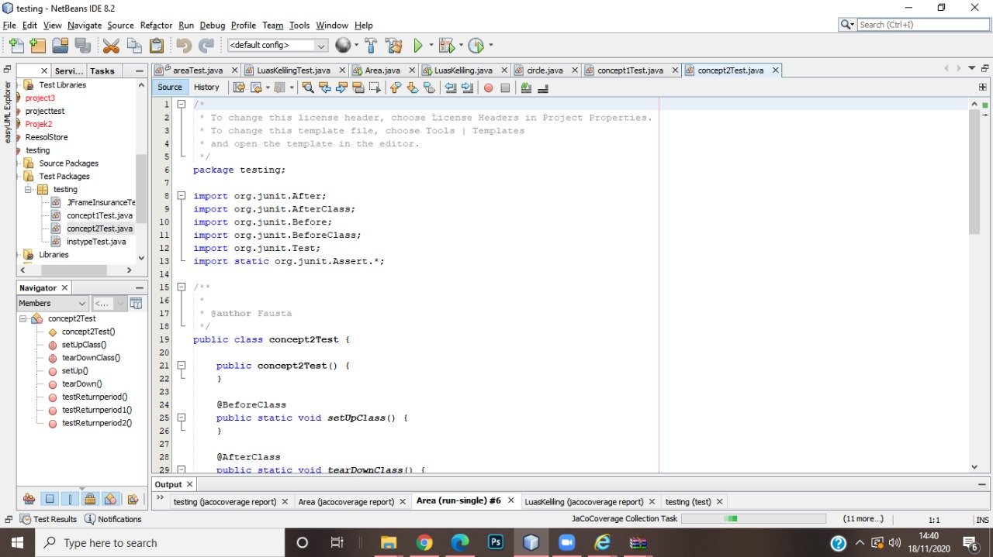

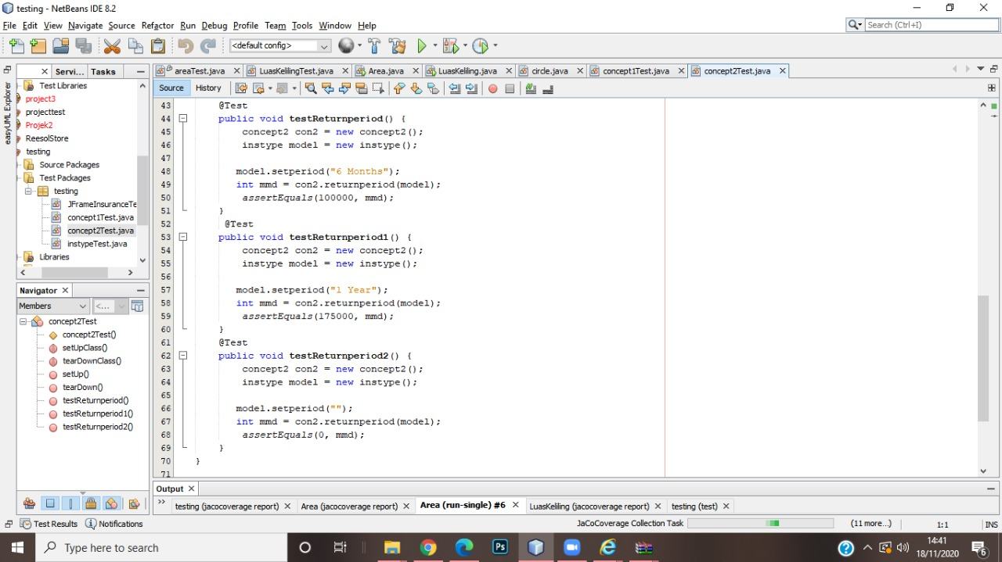

**TESTING IMPLEMENTATION**

|  |  |  |  |  |  |
| --- | --- | --- | --- | --- | --- |
| No | Test Scenarios | Test Case | Expected results | Test Results | Conclusion |
| 1 | Not fill the“Type of Item”and click the “OK” button | WhatsApp Image 2020-11-18 at 10.14.46 | the system will deny the access, and it will appear "Please input the Item Type" | WhatsApp Image 2020-11-18 at 10.15.29 | valid |
| 2 | Not fill the“Plan”and click the “OK” button | WhatsApp Image 2020-11-18 at 10.14.46 | the system will deny the access, and it will appear "Please Choose Your Plan" | WhatsApp Image 2020-11-18 at 10.15.39 | valid |
| 3 | Fill the “Type of Item (iPhone 12)”,“Plan (One Time Insurance)”, “Insurance Package (Silver)”, and “Insurance Period (6 months)”and the click the “OK” button | WhatsApp Image 2020-11-18 at 10.16.21 | the system will gives the total price in “Total” column. | WhatsApp Image 2020-11-18 at 10.16.21 | valid |
| 4 | Click the “Clear”button | WhatsApp Image 2020-11-18 at 10.14.46 | the system will reset all the choices | WhatsApp Image 2020-11-18 at 10.14.46 | valid |
| 5 | Fill the “Type of Item (iPhone 12)”,“Plan (Subscribe Plan)”, “Insurance Package (Silver)”, and “Insurance Period (6 months)”and the click the “OK” button | WhatsApp Image 2020-11-18 at 10.16.35 | the system will gives the total price in “Total” column. | WhatsApp Image 2020-11-18 at 10.16.35 | valid |

**TESTING IMPLEMENTATION**

|  |  |  |  |  |  |
| --- | --- | --- | --- | --- | --- |
| 6 | Fill the “Type of Item (iPhone 12)”,“Plan (Subscribe Plan)”, “Insurance Package (Gold)”, and “Insurance Period (6 months)”and the click the “OK” button | WhatsApp Image 2020-11-18 at 10.18.04 | the system will gives the total price in “Total” column. | WhatsApp Image 2020-11-18 at 10.18.04 | valid |
| 7 | Fill the “Type of Item (iPhone 12)”,“Plan (One Time Insurance)”, “Insurance Package (Gold)”, and “Insurance Period (6 months)”and the click the “OK” button | WhatsApp Image 2020-11-18 at 10.18.39 | the system will gives the total price in “Total” column. | WhatsApp Image 2020-11-18 at 10.18.39 | valid |
| 8 | Fill the “Type of Item (iPhone 12)”,“Plan (One Time Insurance)”, “Insurance Package (Silver)”, and “Insurance Period (1 Year)”and the click the “OK” button | WhatsApp Image 2020-11-18 at 10.19.12 | the system will gives the total price in “Total” column. | WhatsApp Image 2020-11-18 at 10.19.12 | valid |
| 9 | Fill the “Type of Item (iPhone 12)”,“Plan (Subscribe Plan)”, “Insurance Package (Silver)”, and “Insurance Period (1 Year)”and the click the “OK” button | WhatsApp Image 2020-11-18 at 10.19.25 | the system will gives the total price in “Total” column. | WhatsApp Image 2020-11-18 at 10.19.25 | valid |

**TESTING IMPLEMENTATION**

|  |  |  |  |  |  |
| --- | --- | --- | --- | --- | --- |
| 10 | Fill the “Type of Item (iPhone 12)”,“Plan (One Time Insurance)”, “Insurance Package (Gold)”, and “Insurance Period (1 Year)”and the click the “OK” button | WhatsApp Image 2020-11-18 at 10.19.43 | the system will gives the total price in “Total” column. | WhatsApp Image 2020-11-18 at 10.19.43 | valid |
| 11 | Fill the “Type of Item (iPhone 12)”,“Plan (Subscribe Plan)”, “Insurance Package (Gold)”, and “Insurance Period (1 Year)”and the click the “OK” button | WhatsApp Image 2020-11-18 at 10.20.53 | the system will gives the total price in “Total” column. | WhatsApp Image 2020-11-18 at 10.20.53 | valid |

**RESULT**

Result Junit Testing

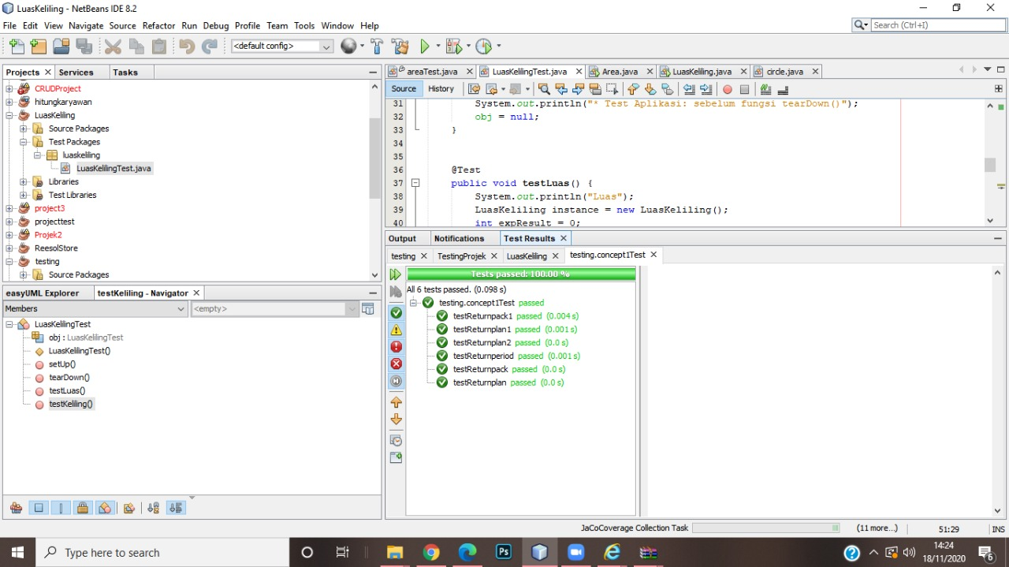

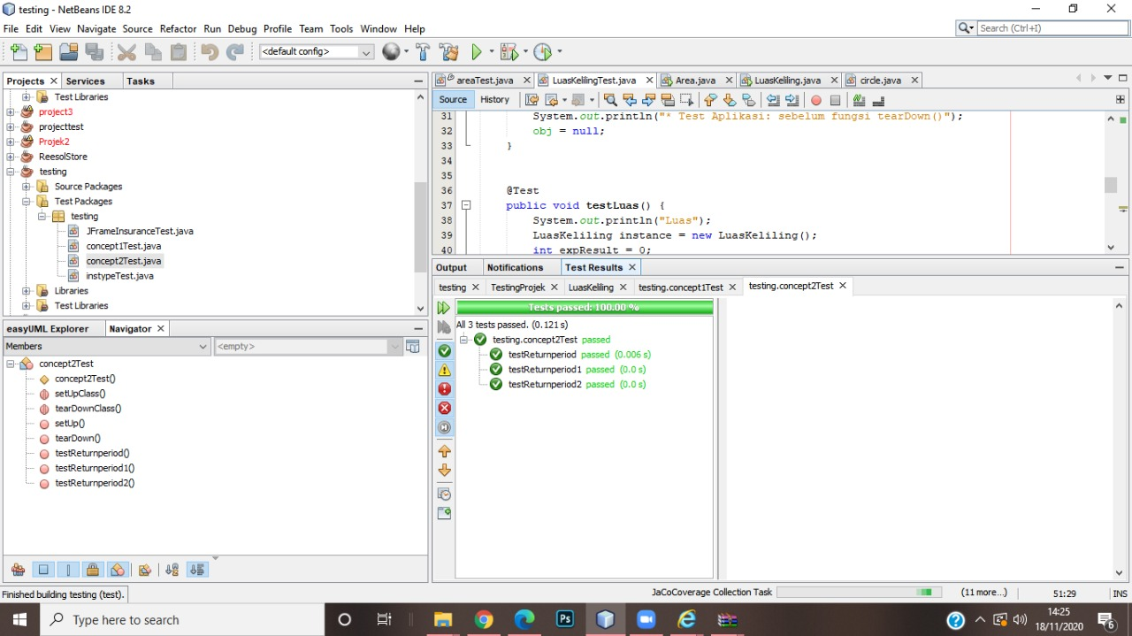

**RESULT JaCoCo**

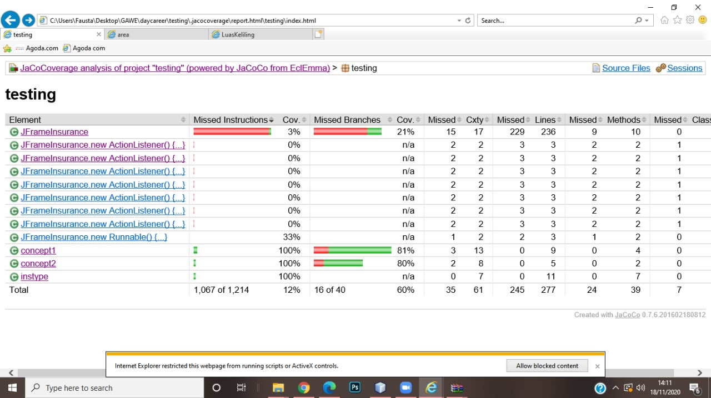

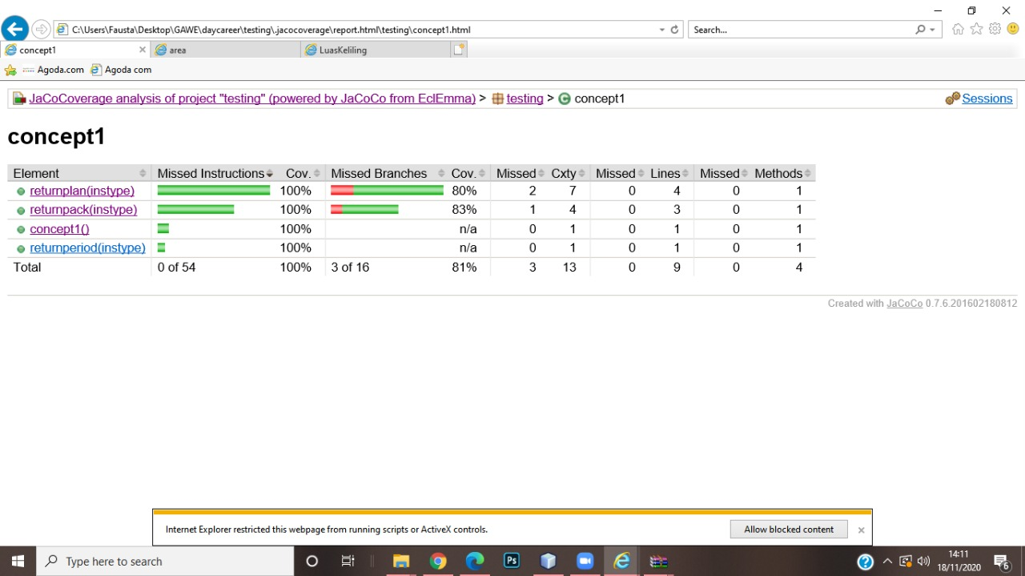

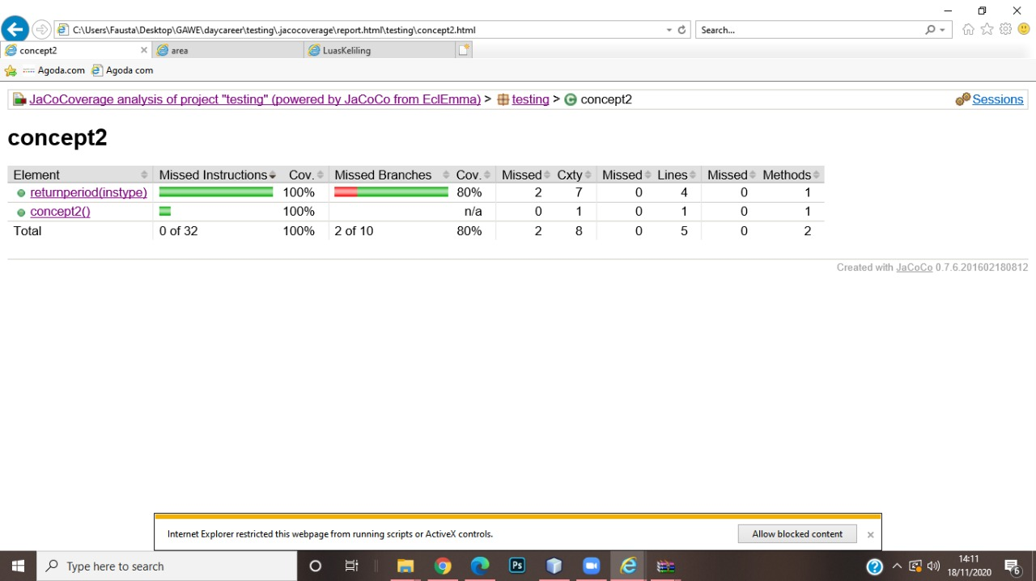

**RESULT JaCoCo**

